Mutation Driven Fitness Simulations of Co-evolutionary Dynamics in a Two-species Model

Kinshuk Sahu1, Iris Ziyi Wang1

1University of California, San Diego

# ABSTRACT

The vast majority of organisms on our planet live in ecological communities, and they can adapt by accumulating mutations that improve their fitness. These mutations can then change the ecological interactions with other species in the system, giving rise to co-evolutionary dynamics such as evolutionary stasis or the Red-Queen type of continuous evolution. However, which conditions produce these scenarios are unknown. In this paper, we explore this question using computer simulations of mutations and species fitness in a simple two-species model. We find that while increase in synergistic mutations would lead to stasis, increase in antagonistic mutations shift the system towards the Red-Queen type of continuous evolution under diminishing returns epistasis.

# **INTRODUCTION**

The vast majority of organisms on our planet live in ecological communities, and they can adapt by accumulating mutations that improve their fitness. These mutations can then change the environment and the ecological interactions (positive or negative) with other species in the community, contributing to adaptation. In the study of such co-evolutionary dynamics within a multispecies ecological community, there are two major long term outcomes: stasis or Red-Queen type of continuous evolution (1). Stasis refers to a cease of all species’ evolution or respective fitness in the system, while the Red-Queen type of continuous evolution, presented by Leigh Van Valen in 1973, refers to a forever changing of  species’ respective fitness in the system (2, 3).

The fundamental question of what conditions will produce each of the outcomes was first tackled by Stenseth and Smith in 1984, and they showed that a model with biotically driven evolution can result in both the Red-Queen type of continuous evolution and stasis (1). Nordbotten and Stenseth in 2016 further showed that asymmetric ecological conditions favor the Red-Queen type of continuous evolution over stasis while stasis mainly occurs in systems only containing symmetric ecological interactions (3). However, till now, we still do not quite know the answer to this question. It is also intrinsically interesting to know how species can continue evolving forever in the real world. Lenski in 2013 showed fitness of asexual population seems to continue increasing without an upper bound (4), suggesting Red-Queen type of continuous evolution might be realistic in our ecosystems. Some groups have considered a take on this subject using game theory evolutionary dynamics, involves calculation of a payoff matrix and a replicator equation (5), recent works take into account polymorphic populations and points towards a scenario of continued evolution through fast positive and slow negative feedback (6).

Since mutation is the crucial and foundational supply for evolution, instead of focusing on the effect of biotic and abiotic interactions, we consider a simple model with the effect of mutations on the co-evolutionary dynamics and the corresponding change in species ecological interactions, either positive or negative. We did this since we wanted to answer a more fundamental question by not restricting the cause of mutation. More specifically, in this paper, we explore the conditions for stasis and continuous evolution using computer simulations of species fitness in a simple two-species model.

# **METHODS**

(Source code available at <https://github.com/iriswangziyi/BGGN212-Coevolution/releases/tag/v1.0>)

In order to use mutations to depict the positive or negative ecological interactions within our simple two-species model, we term mutation as either antagonistic or synergistic, rather than referring to it as beneficial, deleterious, or neutral. An antagonistic mutation of species 1 (A1) will increase the fitness of Species 1 by one, and decrease the fitness of Species 2 by one; An synergistic mutation of species 1 (S1) will increase the fitness of Species 1 by one, and also increase the fitness of Species 2 by one. Antagonistic and synergistic mutation of species 2 (A2, S2) follows in a similar logic (Table 1). Mutation is generated randomly using the Gillespie algorithm, and therefore at any given time, one of the four types of mutation will randomly occur in the system and cause an ecological interaction change in terms of change in both species’ fitness. Fitness of each species is measured in the computer simulation to describe species interactions. In our model, both Species 1 and Species 2 start with a fitness of 10, which is a randomly chosen number. When fitness of one species reaches 0, it is extinct in the system.

|  |  |  |  |
| --- | --- | --- | --- |
| **Types of Mutation** | **Fitness of Species 1 (X)** | **Fitness of Species 2 (Y)** | **Mutation rates** |
| **A**ntagonistic (**A1**) | X → X + 1 | Y → Y - 1 | U1a(x) |
| **S**ynergistic (**S1**) | X → X + 1 | Y → Y + 1 | U1s(x) |
| **A**ntagonistic (**A2**) | X → X - 1 | Y → Y + 1 | U2a(Y) |
| **S**ynergistic (**S1**) | X → X + 1 | Y → Y + 1 | U2s(Y) |

Table 1. The relationship between fitness of species and mutation rates in the two-species model.

With this basic model in place, we then tried to answer our overarching problem by changing the function of the mutation rates, since different conditions of the two-species system would be depicted by different rates of mutation. There are two general scenarios for the mutation rate: either a constant function with respect to time or a fitness dependent function with diminishing returns epistasis. Diminishing returns epistasis refers to the decreases in the number of mutations as the fitness of a population increases, which is commonly observed in beneficial mutations. We incorporate this into our model through a decreasing function with respect to fitness. As described earlier, the Gillespie algorithm randomly generates a particular type of mutation out of A1, S1, A2, S2 based on the probability given by its rate in proportion to the total mutation rate. A change in proportions will cause a change in the outcome of the simulations.

For simplicity's sake, we are assuming only symmetric behaviour for both the ecological interactions, meaning the proportion of synergistic to antagonistic mutations will be given by the same functions for both the species. This may still bring a change in the synergistic rates of two species due to the fitness dependent mutation function. For scenarios involving diminishing return epistasis, in order to capture different co-evolutionary dynamics trends, mutation rate is represented by a linearly decreasing function instead of an exponentially decreasing function.

In the simulations, four different types of graphs are plotted to observe interaction dynamics: inter-species fitness plot, where species fitness vary with respect to each other, species fitness dynamics with respect to time (including the average fitness over 100 realizations), mutation rates of Species 1 with respect to time, and mutation rates of Species 2 with respect to time. The mutation rate graphs are plot to visualize how mutation rates change with time in response to fitness, especially for scenarios where we have mutation rates as a function of fitness.

# **RESULTS AND DISCUSSION**

For the inter-species fitness plot, S1 and S2 mutations lead to positive diagonal movements upwards along the line with a slope of +1, while A1 and A2 lead to upward or downward negative diagonal movements respectively along the line with a slope of -1 (Fig.1). There is no movement down the positive diagonal, meaning fitness of both species do not decreases at the same time, as beneficial mutations exist for at least one species according to our model.

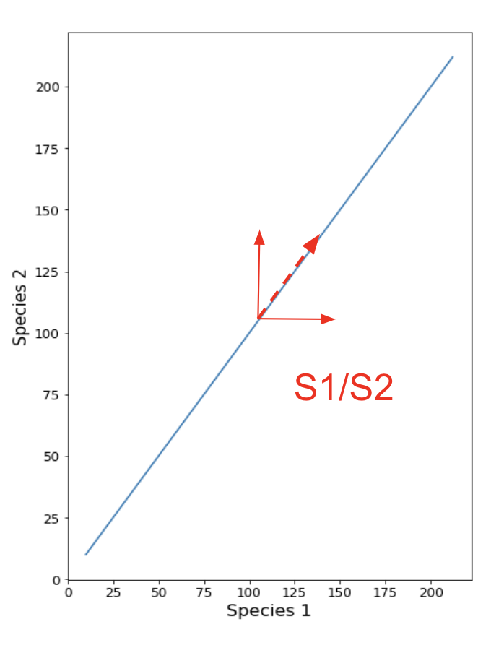

Fig.1. Vector diagram on top of In inter-species fitness plots. S1 and S2 mutations lead to positive diagonal movements while A1 and A2 lead to upward or downward negative diagonal movements.

## **Under constant mutation rates**

Starting from the simplest scenarios of just synergistic and antagonistic mutations with constant mutation rates, as expected, these plots show a movement along the positive diagonal and along the negative diagonal respectively in the species plots (Fig.S1a and Fig.S2a in the supplementary). These dynamics graphs shows in the just symmetric mutations case, there is continued evolution and for the just antagonistic mutations there is extinction in one of the species (Fig.S1b and S2b).

Equal rates of both types of mutations (S1 vs. A1 and S2 vs. A2) make the species variation graph move up along the positive diagonal with slight deviations up or down along the negative diagonal (Fig.S3a). In the vector diagram (Fig.1) there is a net movement upwards of the positive diagonal as the up and down movement along the negative diagonals tend to cancel each other out in the long run. In accordance with the trend of the inter-species fitness plots, the species fitness dynamics plot displays continued evolution for both the species (Fig.S3b).

We observed an interesting behavior when the proportion of antagonist mutation rates increases, some realizations show extinction in one of the species shown by movement along the negative diagonal in the species variation plot and the fitness of one species reaching zero in the dynamics plot (Fig.2a, Fig.2b). However, in some other realizations, the species overcame the initial period where they can easily go extinct, and both survived till the end time point in our simulations (Fig.2c, Fig.2d). Although the probability of extinction depends on the parameter values used in our simulation, the probability of extinction is still non-zero. Thus, under constant mutation rates, both continued evolution and extinction occurs.

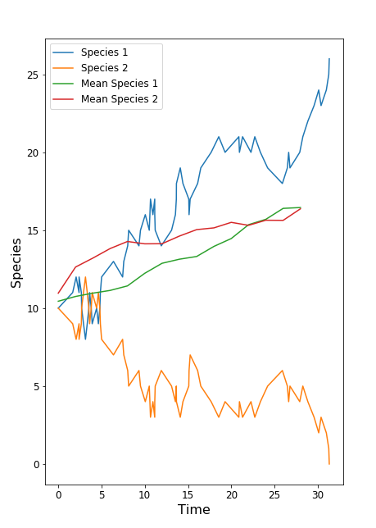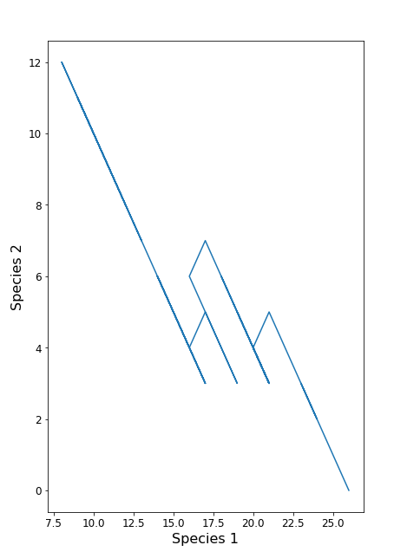

1. (b)

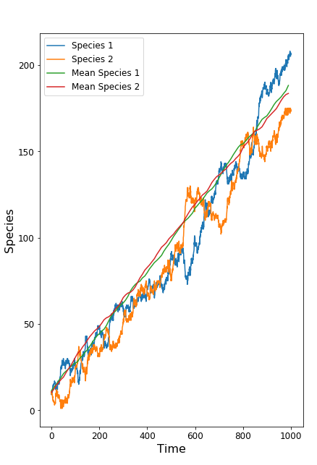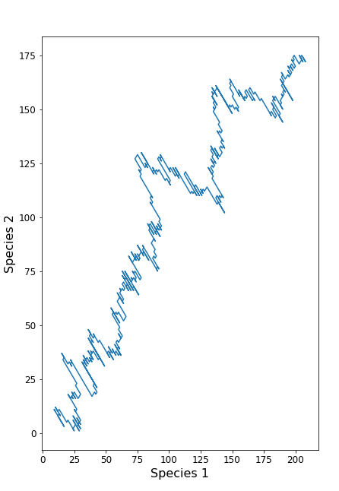

(c) (d)

Fig.2. (a) and (c) shows the inter-species fitness plot for different realizations. (b) and (d) are the corresponding species fitness dynamics plots. We tuned the parameters such that there is more movement along the negative diagonal and slight movement along positive. In some realizations, such as (a), movement along the negative diagonal brings about extinction in one species, also visible in the species fitness dynamics plot shown in (b). In other realizations, shown in inter-species fitness plot in (c) and its corresponding species fitness dynamics plot shown in (d), both species survive and there is continued evolution.

**Under fitness dependent mutation rate**

If the mutation rates depend on fitness according to the diminishing returns epistasis, there are noticeable differences compared to the cases shown in the previous section. The case with only synergistic mutations soon approaches a stasis, as the rate of mutations drop down to zero. The case with only antagonist mutations takes a slightly longer time to go extinct compared to the case shown in the previous section. This is due to the increase in antagonist mutation rate for the species in decline, which results in more oscillations in the inter-species fitness plot, but since this mutation does not increase or decrease much, the probability of extinction in the simulations is still zero. The case involving both mutations at 50 percent also achieved stasis in all of our realizations (Fig.S4 and Fig.S5).

When antagonistic mutations rate is higher than synergistic mutations rate, meaning antagonistic mutation rate decreases slower than the synergistic mutation rate, interestingly, synergistic mutation rate soon falls to almost zero for both species (Fig.3c, Fig.3d). The inter-species fitness behavior (Fig.3a, Fig.3b) is similar to the antagonistic only case in this section, but it differs when one species’ population decreases to a certain level, as all mutation rates of this particular species suddenly increase corresponding to the decreasing function of fitness dependent mutation rate. As a result, fitness of that particular species increases, and it is saved from extinction. The short bursts in the mutation rate graph shows times when this “saving” event occurs (Fig.3c, Fig.3d). In this case, the co-evolutionary dynamics follows the pattern can be described by the Red-Queen type of continuous evolution, species fitness or interactions never ceases.

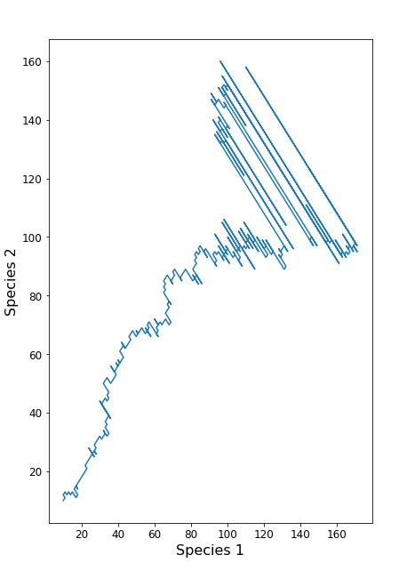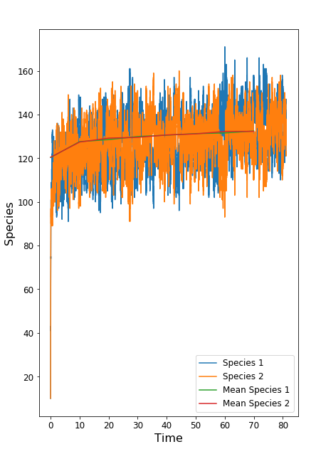

1. (b)

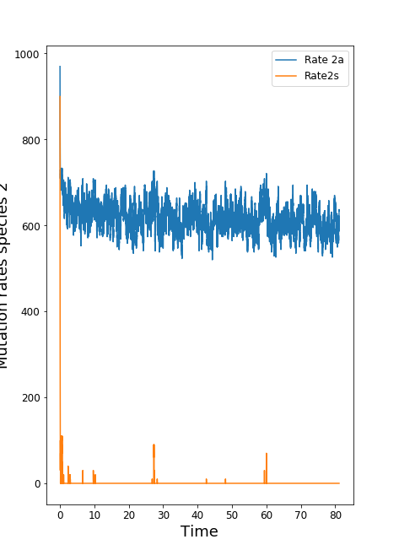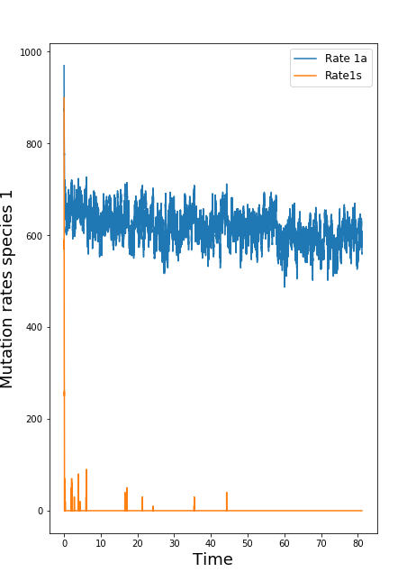

(c) (d)

Fig 3: (a) and (b) show the inter-species fitness plot and species fitness dynamics plot respectively. (c) and (d) show how mutation rate changes with respect to time as the fitness increases. In the beginning, synergistic and antagonistic mutation rates are equal, resulting in a net movement along the positive diagonal, but antagonistic mutations decrease at a lower rate as fitness increases, then antagonistic mutation dominates in both species, resulting in a movement along the negative diagonal as in (a). No realization of those simulated showed extinction in either of the species (Realizations = 100) and the average of all the realizations is also depicted in (b).

On the contrary, when synergistic mutations rate is higher than antagonist mutations rate, the antagonist mutations start to dominate as the fitness increases (Fig.4c, Fig.4d), and later the fitness of both species reach a state (Fig.4a, Fig.4b) similar to the previous case (Fig.3a, Fig.3b), where evolution continues for both species. In the species fitness dynamics plot (Fig.4b), the coarse lines represent small ups and downs of the fitness fluctuation. In the long term, although the curve flattens off, there is no net increase in fitness and species fitness keeps fluctuating (Fig.4b). Therefore, in this case, the co-evolutionary dynamics also follows the Red-Queen type of continuous evolution.

We simulated this case because this situation more closely resembles what may happen to two coevolving species which have a symbiotic relationship. As the fitness increases, they both start to accumulate antagonist mutations so that the other one doesn’t reach the fitness maxima and they turn into hostile species. So, evolution follows the Red-Queen type of continuous evolution in this case. Turning cooperative relationships towards competitive may happen if reaching the fitness maxima enables the species to reduce its dependence on the other species.

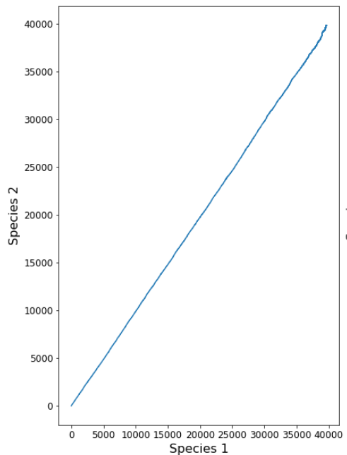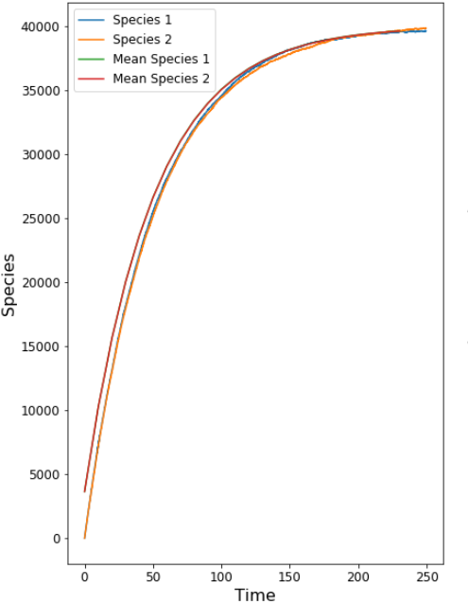

(a) (b)

# 

# 

(c) (d)

Fig 4: (a) and (b) show the inter-species fitness plot and species fitness dynamics plot respectively.

(c) and (d) show how the mutation rate changes with respect to time as the fitness increases. Here, we observe a continued evolution as evident in (b), which is essentially similar to Fig.3b, just that the variation is small as compared to the fitness levels.

# **CONCLUSION**

After simulating different scenarios, we come to a preliminary conclusion to our overarching question. To achieve evolution following the ideology of the Red-Queen type of continuous evolution or evolutionary stasis will depend on the rate of mutations. If there is an unending supply of mutations (constant mutation rate), then synergistic mutations lead to continued evolution and we can never achieve stasis, as evolution ceases only if antagonistic mutations increase leading to extinction in one species. On the other hand if we follow the law of diminishing returns (fitness dependent mutation rate), when both synergistic and antagonistic mutation present in the system, the increase in the synergistic mutations would lead to stasis behaviour and increase in antagonistic mutations shift the system towards continuous evolution.

Furthermore, in the case of fitness dependent mutation rate, we can classify the co-evolutionary system as either cooperative or competitive. Cooperative species will reach a stasis if it has only synergistic or mostly synergistic mutations, and if antagonistic mutations rise later as fitness increases, there will be continued evolution under the Red-Queen type of continuous evolution. Competitive species will result in the extinction of one species, if there are only antagonistic mutations, and if antagonist mutations are dominate compared to the synergistic mutations from the start, there will be continued evolution through the Red-Queen type of continuous evolution.

Our model does not consider the case of neutral mutation, and it could be a future direction as the accumulation of neutral mutations will increase one species fitness, which can affect its fitness dependent mutation rates and future change the co-evolutionary dynamics with other species in the system. Another direction of our study can be exploring the different diminishing function of mutation rates in the simulation, as we only considered linearly decreasing function. Our research developed a simple two-species model to study co-evolutionary dynamics and it provides insights for understanding the conditions for evolutionary stasis and the Red-Queen type of continuous evolution.

# **REFERENCES**

1. Stenseth NC, Maynard Smith J (1984). Coevolution in ecosystems: Red Queen evolution or stasis? [*Evolution* 38(4):870-80](https://onlinelibrary.wiley.com/doi/abs/10.1111/j.1558-5646.1984.tb00358.x)
2. Van Valen L (1973) A new evolutionary law. Evol Theory 1:1–30.
3. Nordbotten JM, Stenseth NC (2016). Asymmetric ecological conditions favor Red-Queen type of continued evolution over stasis. [*PNAS* 113(7):1847-52](https://www.pnas.org/content/113/7/1847.short)
4. Wiser, M. J., Ribeck, N., & Lenski, R. E. (2013). Long-term dynamics of adaptation in asexual populations. Science, 342(6164), 1364-1367.
5. Traulsen, A., Claussen, J. C., & Hauert, C. (2005). Coevolutionary dynamics: from finite to infinite populations. *Physical review letters*, *95*(23), 238701.
6. Wortel, M.T., Peters, H., Bonachela, J.A. and Stenseth, N.C., 2020. Continual evolution through coupled fast and slow feedbacks. *Proceedings of the National Academy of Sciences*, *117*(8), pp.4234-4242.

**Supplementary figures**

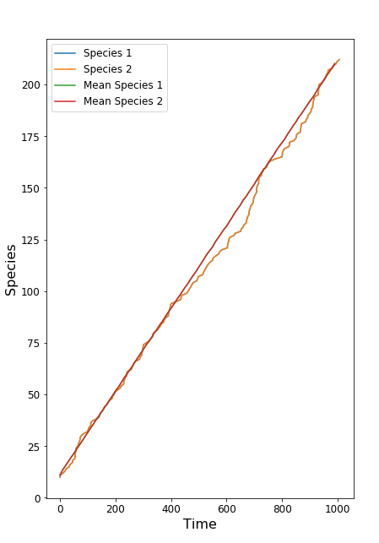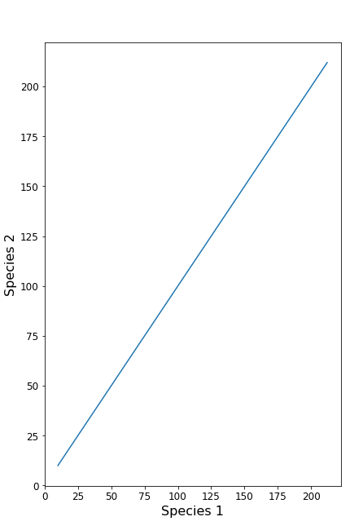

1. (b)

Fig.S1: Only synergistic mutations under constant mutation rate.

(a) shows the inter-species fitness plot and (b) shows the species fitness dynamics plot.

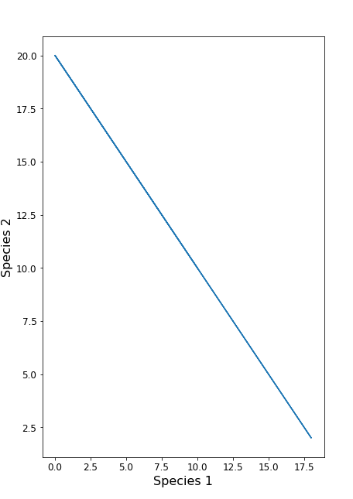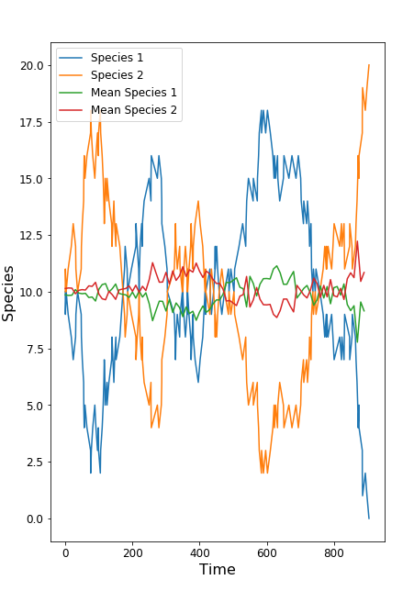

# 

# 

# (b)

Fig.S2: Only antagonistic mutations under constant mutation rate.

(a) shows the inter-species fitness plot and (b) shows the species fitness dynamics plot.

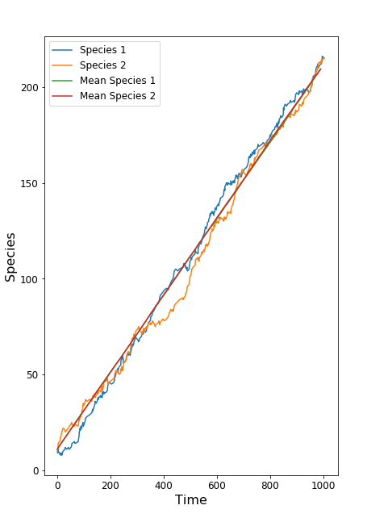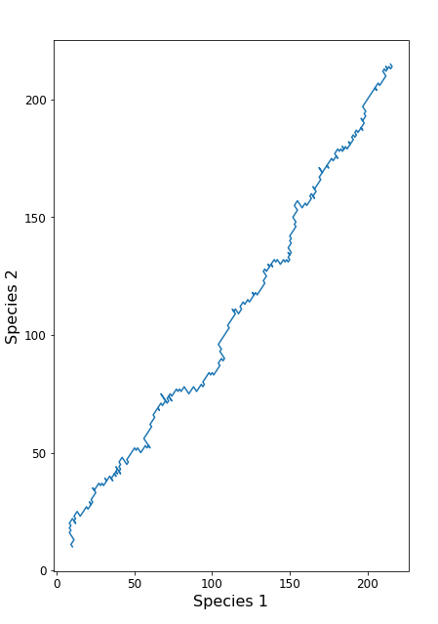

# 

# 

# 

1. (b)

Fig.S3: 50 percent of each antagonistic and synergistic mutations under constant mutation rate.

(a) shows the inter-species fitness plot and (b) shows the species fitness dynamics plot.

# https://lh3.googleusercontent.com/PkBR7PWjO2PdAuXNRummeolF8l_bgmZveRe2g7FNEo40vJ6GEc647J_RB0Yg6nxGDSTsE6YcgbXcSy5Id9j-n1A6oiEfU5vAhlexW1zJ6C_6Zu_drOABDPMq3ty5FeVvM70wlYZloaYhttps://lh3.googleusercontent.com/698AY1sQhET3XadPE6MHLKMKQ4agRBlPsaVjyriRP-_Zy90B-k-3olBFfliKhb_1gBHaI44pEMxSJpXvbExNE8UOz0Ttb5xlPlWhVXcBV7GON2TPZzrTSof9oZLQ1Q7JFlVG1MukGSI

1. (b)

# https://lh3.googleusercontent.com/etuTuTW5CSkfNwONGX2torvFrgeth3avNbmS3vc2xXX0kRKNIpAIWeRr8Z3sB4XqpijaEdnPipWcCSGKuhN0GXlCxe5Ouz0cNHZY_kAib4jFnlxoLR1RCKW0FON28762VnA1fqqv94khttps://lh4.googleusercontent.com/U3zdzMGUD3GoTE5zs5LF2xouiGaPxLluqv7uSv2mnthyaEnfGTzZ0YSphg_GH81mfDtpdORMBFf5Z1ZfMmNBqhpfTGj-qrty_rFnwYElNMxknbUUEjIHyItJHjQQZMdV6ImFga6XoBg

(c) (d)

Fig.S4: Antagonistic only mutations under fitness dependent mutation rates. (a) shows the inter-species fitness plot and (b) shows the species fitness dynamics plot, (c) and (d) show the mutation variation plots of species 1 and species 2 respectively.

# https://lh5.googleusercontent.com/bDCh3F_W6nZeeOmJTYm958fGO5FFHj5kfdAAmiRtcVtphYRHNwmW2HVdUm_d8WhJ4FOWbWoBUYL0q6OXoTWyHW1QsvZ54nYzVl-kGWZEUgxJFYbJe_uQNpjM0-EcqyVkPCAHzVta2Hchttps://lh3.googleusercontent.com/yPk0l9gEzr8c5jaWUZT5HTrPiTjHXgJmT6C5cmf5jw8jD2y-8eUCqaBvBCbWXFe8V_9B7Ql7TrXcaN9uqa1m_AVx5wOMArxDkbf7RI6GxYfvBfsfWwrdgUWYE63OEWC1AkSYlJdABk4

# 

(a) (b)

# https://lh6.googleusercontent.com/BhPxwlFnx36NyhNCvBg2QEJWiC7_7qJFzCnOF9AWPoayplNsMZk_yFFub-CwZz4ZkzYcWxJmDG6pGUdEsU9hO9ItvWItozyJD5ugdps5wTRviI5vSxJMcfW1hNcO2kac7Jwx5_82u2Ihttps://lh3.googleusercontent.com/5CR1ABRttYoeP9kH3NMB9KFcEC6xOaP7GVjqMoB1CXqyKTz2Cgi1OXbqqo5cMBw8OgIiJjgwwPJpk_SH_6_peFqp6kuoWeinj_QGNk4DR30KvsEUtY1eWnjAZQ973ExlH6hypvLOplA

(c) (d)

Fig.S5: 50 percent antagonistic and synergistic mutations under fitness dependent mutation rates.

(a) shows the inter-species fitness plot and (b) shows the species fitness dynamics plot, (c) and (d) show the mutation variation plots of species 1 and species 2 respectively.